Experiment – 9
Question:
Create a Snapshot of a VM and Test it by loading the Previous Version/Cloned VM using virtual box.
Answer:
AIM: To create and allocate a virtual hard disk.
SOFTWARE REQUIRED: Virtual Box, Host OS: Windows
PROCEDURE:
STEP 1: Open VirtualBox
Click Start → Oracle VM VirtualBox
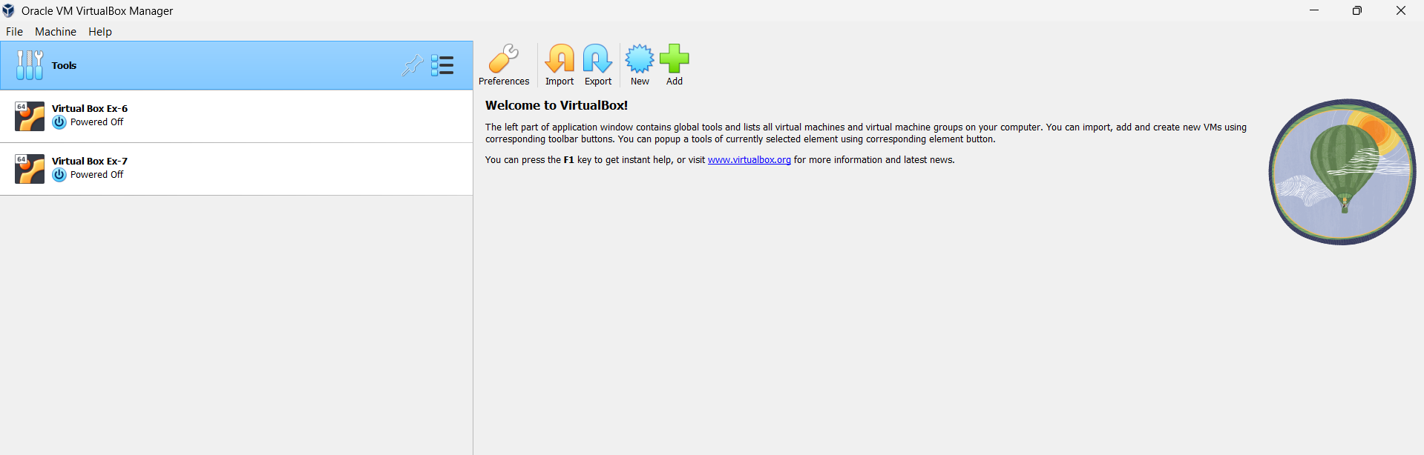

STEP 2: Create New VM
Click New
Name: Virtual Box Ex-9
Type: Linux
Version: Ubuntu (64-bit)
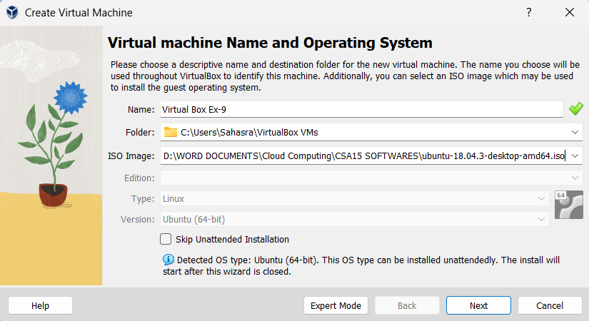
STEP 3: Select ISO File
Click ISO Image
Browse and select Ubuntu ISO
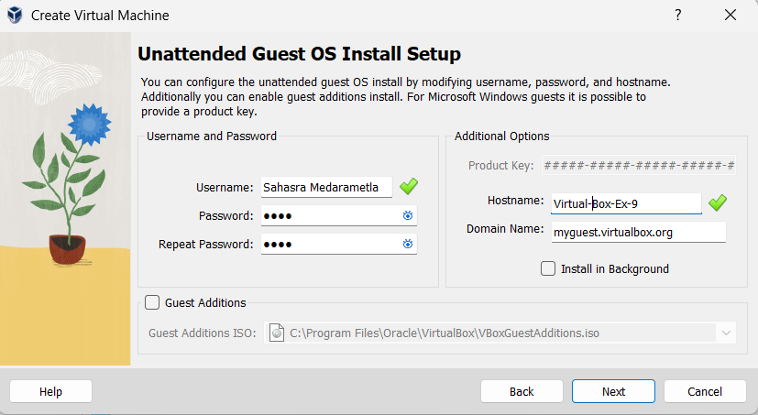
STEP 4: Set CPU = 1
Set Memory = 2048 MB
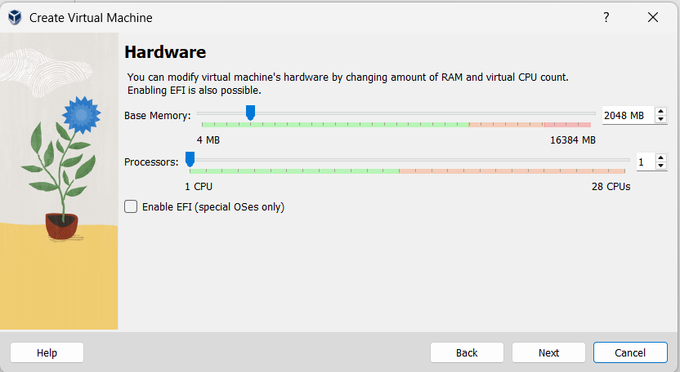
STEP 5: Set Disk Size
Verify disk = 25 GB
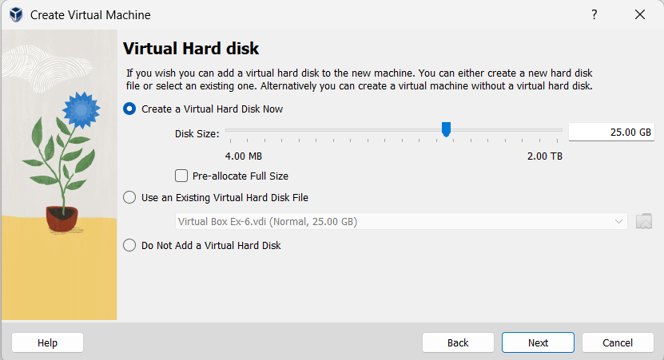

STEP 4: Finish Setup
Click Next → Finish
Click Start to run VM
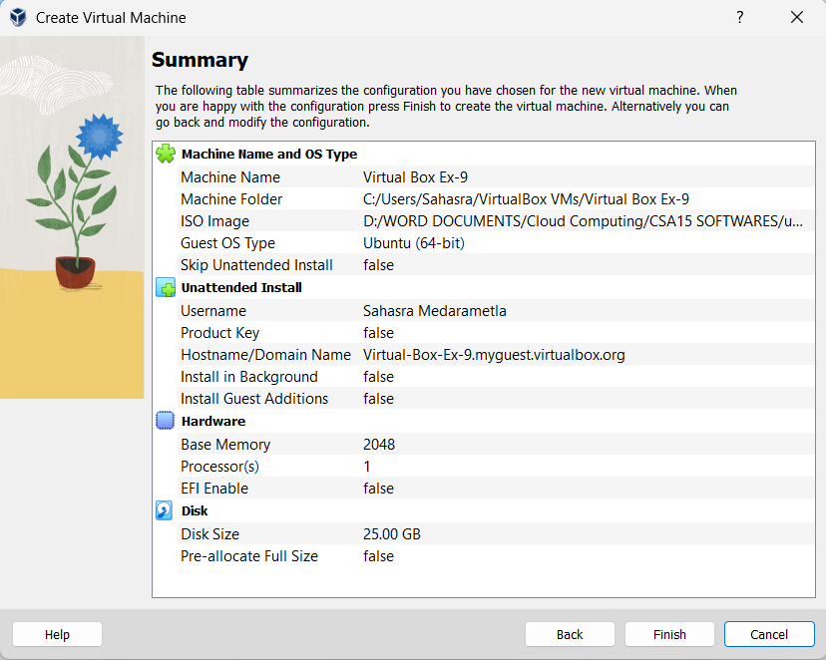
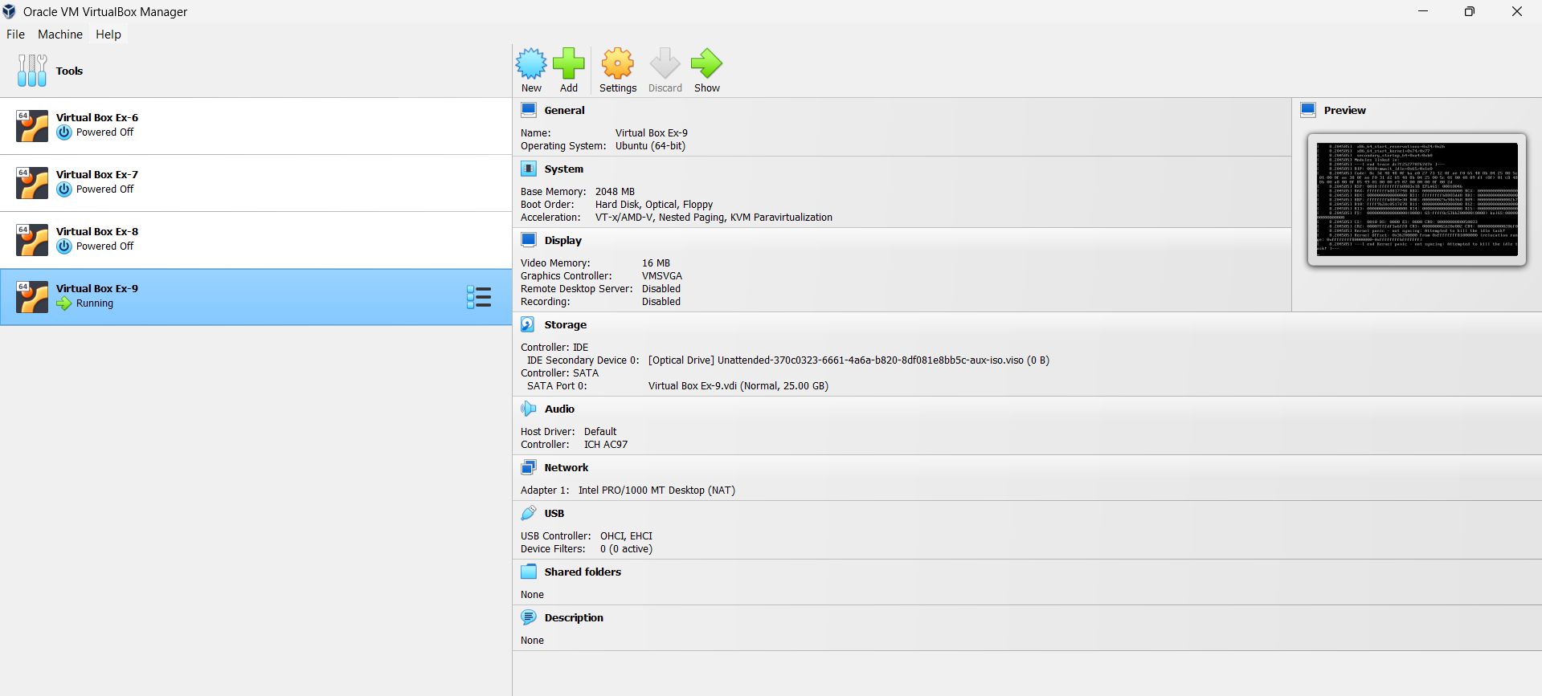
STEP 5: Take Snapshot
Click Machine → Take Snapshot
Name: Snapshot_1
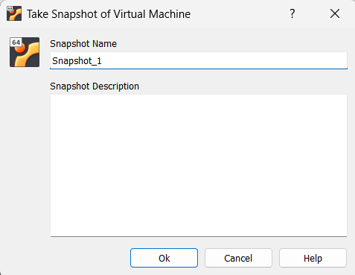
STEP 6: Make Change in Ubuntu
Right-click Desktop → New Folder
Name it Test_Snapshot
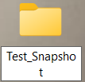
STEP 7: Restore Snapshot
Power OFF VM
Go to Snapshots tab
Select Snapshot_1 → Restore
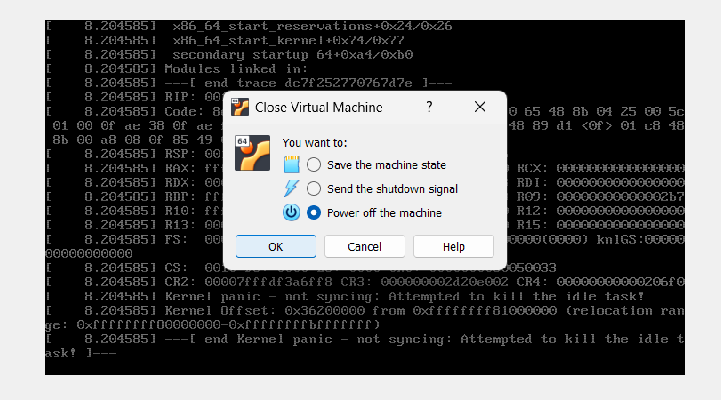
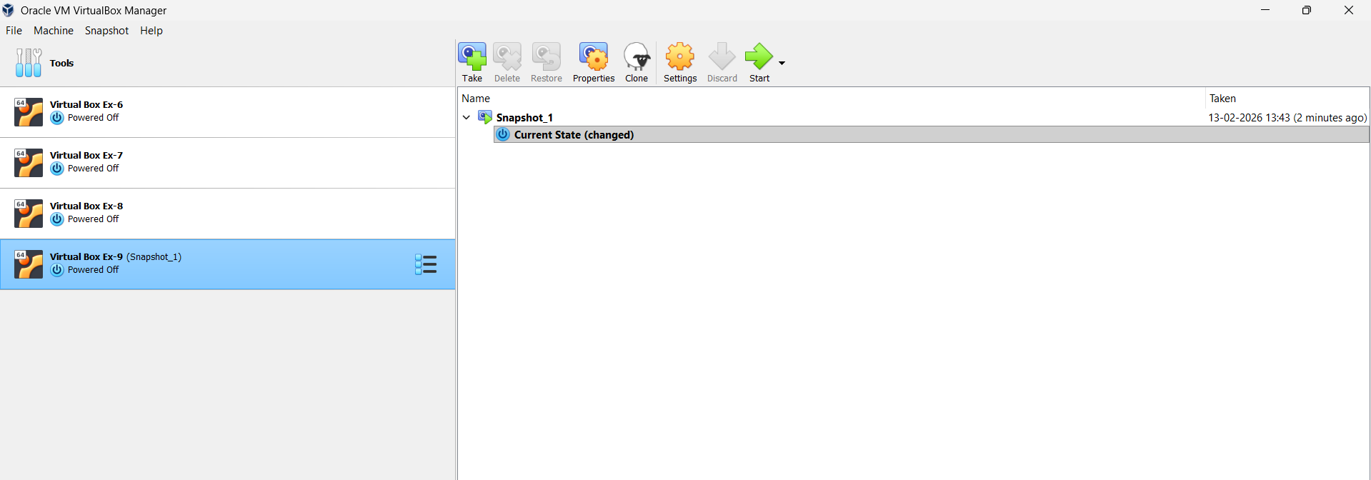
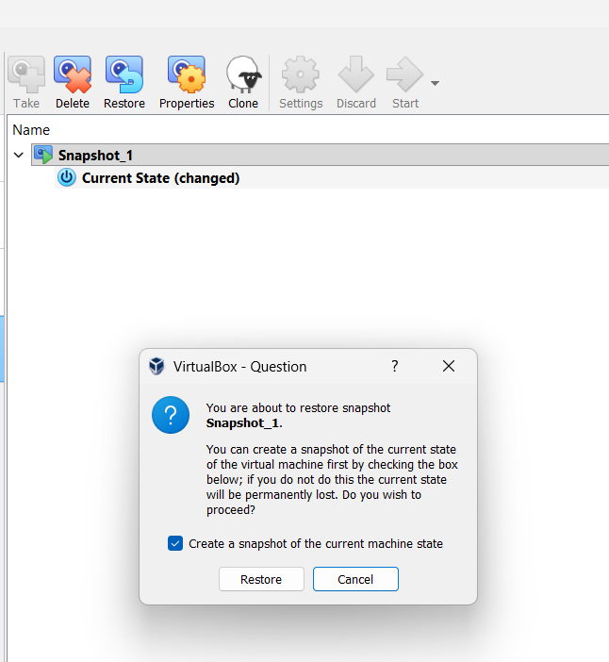
STEP 8: Verify
Start VM
Folder disappears
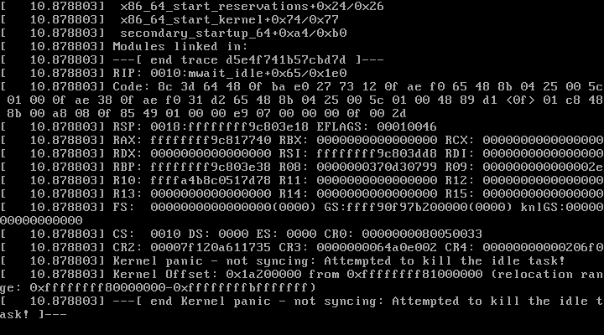
RESULT: Snapshot rollback verified successfully.

